Market Basket Analysis - Discover product associations

Alessandro Arnone and Sergi Planes

2019-12-12

Blackwell Electronics’ board of directors is considering acquiring Electronidex, a start-up electronics online retailer. In order to help Blackwell’s board of directors to have a clearer picture of Electronidex’s customer buying patterns and to support their decision to either purchase or not Electronidex, different analyisis have been carried out :

* A first analysis to understand the typology of customer, the size of the transactions and an idea of their customer/product portfolio
* A basket market analysis to understand how we can leverage the current customer/product portfolio to improve Blackwell

Our analysis is not based on the knowledge of the company’s strategy but simply wants to give insights related to the customer and product base of Electronidex company. We will rate our insights as positive if:

1. **Increase customer base**: with the acquisition of the new company, there is an increase of our customer base
2. **Identify customer profile**: the acquisition will support us in identify and target new customer type ( example: Gamer or Apple Fun)
3. **Strategy Alignment**: the product portfolio of Electronidex will either complement our product portfolio or can be leveraged to offer additional service to our customers
4. **Optimize Product portfolio**: the basket analysis of Electronidex is aligned with Blackwell product portfolio and the analyisis of Electronidex “flop-products” has similiarities with Blackwell’s. This will help us to streamline the offer to our customers and focus on best-selling

### ASSUMPTIONS AND LIMITATIONS

In order to run our analysis, some assumptions have been taken:

* Our dataset includes transactions related to only one month. That means, whilst it can be valuable to understand the health of the company and a good starting point, it might be not sufficient to support the strategic decision to acquire Electronidex
* The transactions dataset have been split in 2 according the target customer that the transaction was related to: **Distributors Transaction (B2B)** and **Final Customer Transaction (B2C)**. Hence, we can define Electronidex as a Business To Many organization (b) In fact, it has been noticed that during our analysis, some transaction were either extremely numerous ( >10 item purchased per transaction) or were including more then one lapton/desktop. This will be our starting point in order to discover the different patterns, the customer profiles and product associations. Therefore the analysis will focus both types (B2B transactions and B2C transactions).

## Increase customer base

Analysing the new dataset, we can see that there are 9833 transactions. If we consider that those transaction are made by unique customers and that every customer purchase electronic goods maximun once a month , we would have 9833 new customers.

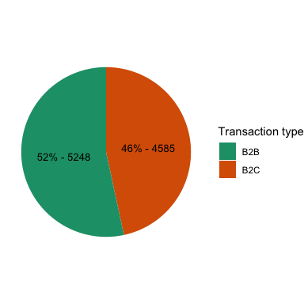

Figure1: # transaction by type.

Moreover, as we can see from the chart above, not only we would have new B2C customers, we will also acquire +5000 customers that operates in the B2B world. This would be a really good addition to our customer base since: - B2B transaction are generally higher in Volume ( # items) than the B2C transactions - We will increase our negotiation power with our supplier (ex: Apple, Acer, etc.) when purchasing higher volume of products

## Identify customer profile

After the analysis of the dataset and based on the type and number of transactions, we can conclude that diffent customer profiles appear. In fact, as mentioned earlier, transactions can be either B2B or B2C.

In B2B we can see that there are 3 customer profile: Gamer Distributor, Apple Distributor, No-Specific Distributor. Those distinction has been built with the following assumption:

1. **Game Distributor transaction**:
   * **At least 1 Gaming Laptop/Desktop** as main product, **plus additional secondary gaming accessories**. Moreover, the 50% of the items of the transaction is a gaming product
2. **Apple Distributor transaction**:
   * **At least 1 Apple Laptop/Desktop** as main product, **plus additional secondary Apple accessories**. Moreover, the 50% of the items of the transaction is an Apple product
3. **No-Specific Distributor**:
   * It does not belong to the above categories

In B2C we can see that there are 3 customer profile: Gamer Customer, Apple Customer, No-Specific Customer

1. **Game Customer transaction**:
   * **1 Gaming Laptop/Desktop** as main product, **plus additional secoundary gaming accessories**
2. **Apple Customer transaction**:
   * At least **1 Apple product**
3. **No-Specific Customer**:
   * It does not belong to the above categories

## Strategy Alignment

At first sight, we can compare the top 5 products of Electronidex with the top 5 products of Blackewell.

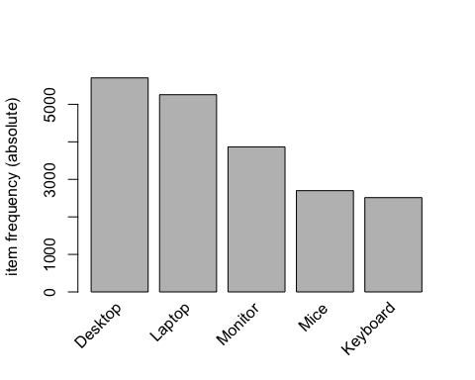

Figure2: #top product category - ELECTRONIDEX

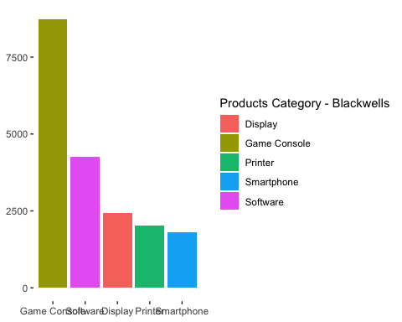

Figure3: #top product category - BLACKWELLS

As we can notice, whilst our company focus on low-end products (our top product category is game console followed by software, display, printer and smartphone), the top products category of Electronidex are Laptop, Desktop and monitor (both in B2B and B2C transactions).

Those category do not cannabilise eachother since they focus in two different markets. That would means that the offering to our customer would potentially increase.

Also we can capitilize on their sales of laptop and computer combined with our expertise in software. In fact, our third revenue stream comes from software. This alone would not justify the acquisition of Electronidex but It can be something to take in consideration in case of cross-selling.

The least sold category product for Electronindex is Computer Game as we can see from the graph below. Further investigation need to be done on our “Software” category. If this category includes also “Computer Game”, we can leverage our expertise in the field to fill this gap.

Additional consideration needs to be made on the category Monitor (in third position for both company volume sales). Likely, we would need to re-organize the product offering in order to optimize our portfolio.

If we put the focus on products in our analysis similiar patterns can be found. Following with the same structure, we can define:

* **B2B product analysis**:

On the top 5 B2B products we find 5 computers/laptops. This is a valuable insight for Blackwell since in the previous studies made by our department, We showed our interest in increase the offering in PC or Laptop. Despite the fact that our survey were run on discovering if the customer were prefering Acer or Sony, these additional brands will anyway contribute to have a wider portfolio.

Additional consideration needs to be made on the product CyberPower Gamer Desktop since our diamond product is a game console (both products specialised in Gaming). These products, if sold in bundle, can give us the opportunity to become a reference in the gamer world distributors.

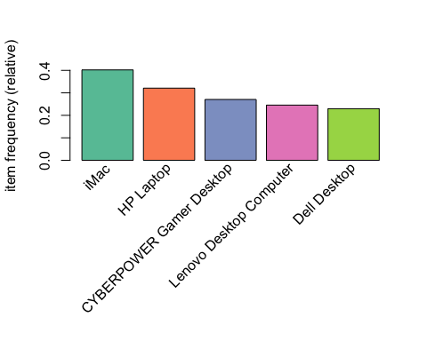

Figure4: #top product B2B - ELECTRONIDEX

* **B2C product analysis**:

On the top 5 B2C products, we can still find computer/laptops but differently from the B2B transactions, Apple Earpods it’s the most sold product. Moreover, 3 out of 5 are Apple products. Hence, Apple is the brand reference for the end client. That means for Blackwell a possibility to increment the offer to clients and to gain traction in high spender customers.

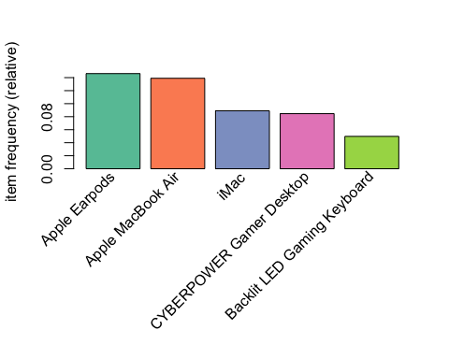

Figure5: #top product B2C - ELECTRONIDEX

## Optimize Product portfolio

Applying the Apriori algorithm we can conclude that:

* It’s likely that a B2B transaction will include a ViewSonic computer when either a laptop or a desktop is purchased. In fact, checking all the possible relations with different products, the only relevant products rule found is the one mentioned above (there is in average 20% possibility that a transaction contain a Viewsonic Monitor when a no-gaming computer is purchased. This likehood increase when additional computers are purchased in the same transactions - up to ~ 40%)

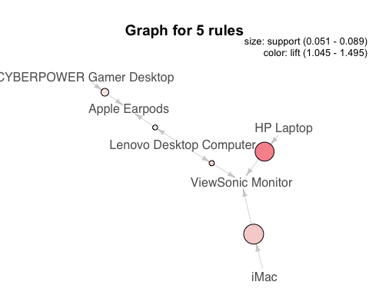

Figure 6: Association Products Rule B2B- ELECTRONIDEX

* In B2C, the strongest product associaction is Apple MacBook Pro, Dell Laptop and Cyber Gamer Desktop with Apple Earpods. It’s interesting to notice that Apple earpods is still the top product also when associated with gaming products. That would mean that this product is successful due to his trasversality and It could work in pair also with our offering (example: our game console). Also, for B2C transaction It looks that it’s more likely that a Samsung monitor is purchased with a CyberPower Gamer Desktop rather than Viewsonic Monitor.

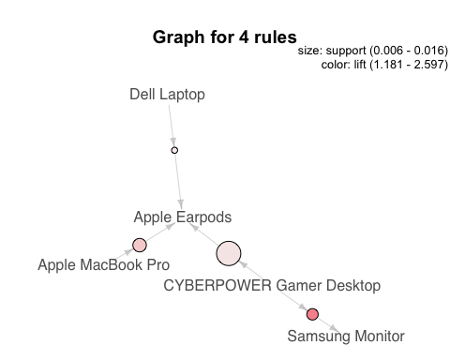

Figure 7: Association Products Rule B2C- ELECTRONIDEX

* Additionally, if we analyse the behaviour of Gamers, we can observe that there is high likehood of purchasing expensive accessories (such as Backlit Led Gaming Keyboard and Microsoft Wireless Desktop Keyboard and Mouse) when a Gaming Desktop or a Gaming Laptop is purchased. These association can benefit the current Blackwell market strategy in order to become leader in the games product offering (assuming that current Gamer in the portfolio of Blackwell will have similiar behaviour)
* Additional notes are needed for categories such as SmartHomeDevices. Not only these products are rarely purchased but also they do not present any specific buying pattern during our analyisis (only a 0.04% likehood to be purchased with Electronindex top product - iMac). Hence those transactions are a a reflection of either impulsive purchase or an off-chance transaction. Hence, if the acquisition goes further, the role of those categories needs to be understood (the same can be said for Tablet, specifically for the product "Kindle )

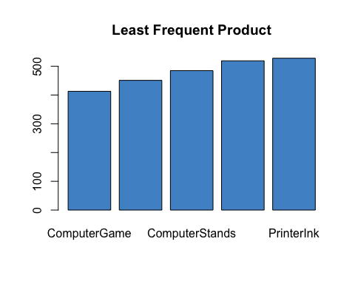

Figure3: #top product category - BLACKWELLS

## Conclusion

We suggest to acquire Electronidex for the following reasons:

* it will allow our company to sell our product also to distributors (from B2C to B2M)
* it will give us a new pool of customers to attain revenue from
* it will bring to the company high spender customers such as Apple-fun and Gamers
* we do not risk market cannibalization since the focus products sold by Electronidex are Laptops and Dekstop
* it will position us as referent company in the gaming world creating a full offer of products (Gaming Laptop/Desktop, Game Console, Games accessories)
* it will enable us to offer complementary products in conjunction to our top best selling (Apple Earpods)